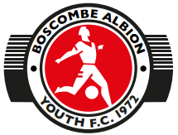

**Sponsorship / Gift Form**

This form is to be used for anybody who wishes to sponsor any Team/Kit/Equipment belonging to Boscombe Albion Youth FC.

This form can also be used for anyone wishing to Gift any Money to the Club.

The Sponsor has the option to advertise its Logo on the Front or Back of the Kit etc

The Kit/Equipment shall remain the Property of Boscombe Albion Youth FC.

|  |  |  |  |  |  |  |
| --- | --- | --- | --- | --- | --- | --- |
| Team | Sponsors Name | Address | e-mail | Telephone | Amount | Bank Details |
|  |  |  |  |  |  |  |
|  |  |  |  |  |  |  |
|  |  |  |  |  |  |  |

Sponsors Signature…………………………………………………………

Treasurers Signature…………………………………………………………